
ATAR Biology

Unit 1: Topic 1
Week 3 – Classification Systems

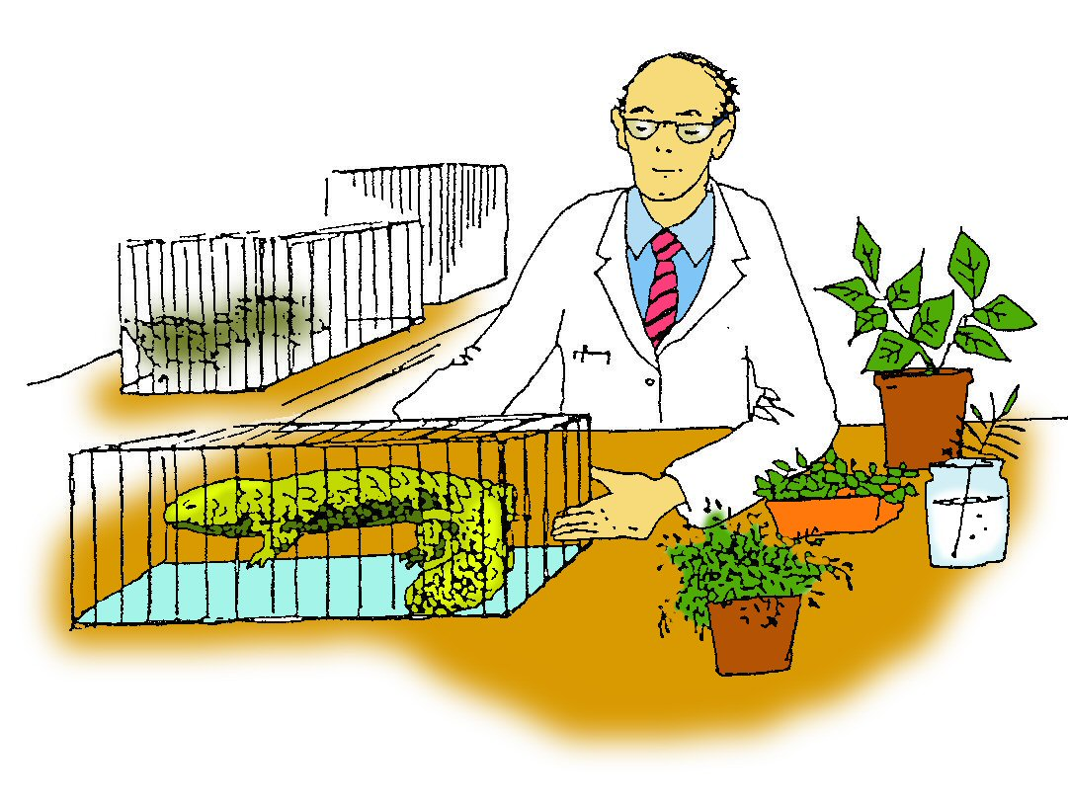

Student Study Notes

Unit Content

- Biological classification is hierarchical and based on molecular sequences, different levels of similarity of physical features and methods of reproduction.
- Most common definitions of species rely on morphological or genetic similarity or the ability to interbreed to produce fertile offspring in natural conditions – but in all cases, exceptions are found.
- Classification systems are based on international conventions and are subject to change through debate and resolution; changes are based on all currently available evidence.

Biological Classification
In this topic you will consider how organisms can be classified into groups and you will need to develop a classification scheme based on information collected during a field excursion.

The activities in this topic and Biological keys in the Biologist’s Toolkit found on Moodle should develop your understanding of classification and assist you in completing the assessment task.

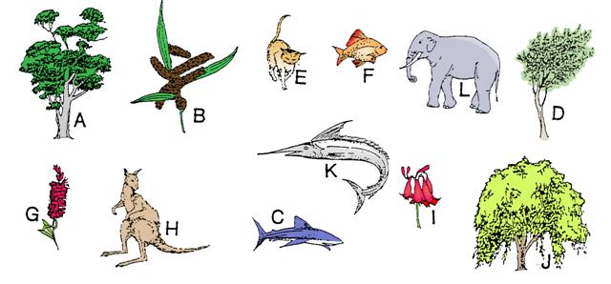
Biological classiﬁcation is the arrangement of organisms into groups that have characteristics in common. Classification is based on identifying similarities and differences between organisms such as structural features and the way an organism feeds, moves or reproduces.
Classification shows relationships between groups of organisms and conveys information about their features and roles in the ecosystem.
For example, the animals below are able to fly but the birds have feathers and lay eggs while the bat has hair and gives birth to live young. The magpie and parrot would be grouped together as they have more characteristics in common with each other than magpies and bats or parrots and bats. This is the basis for a classification system.
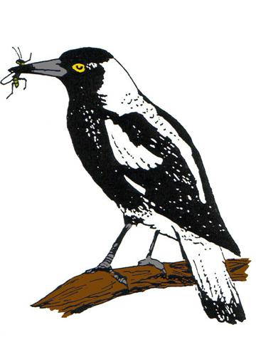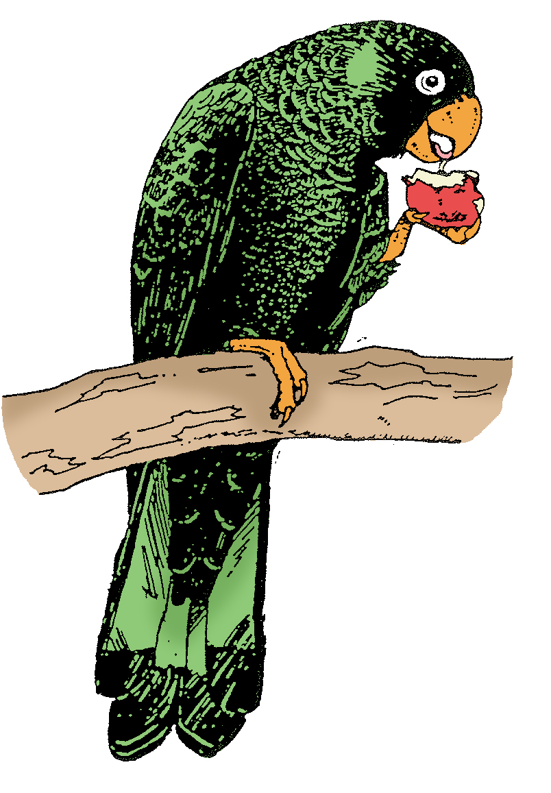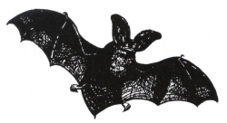

Why classify?
Classification can show structural relationships between groups of organisms such as having a skin covering of hair or feathers.
Classiﬁcation can show feeding relationships between groups of organisms such as autotrophs, heterotrophs and decomposers.
Classiﬁcation can be based on different methods of reproduction between groups of organisms such as internal and external fertilisation.
Classification reduces confusion of identification. Many organisms are known by different common names e g Red gum is a gum tree also known as Marri but it has only one species name Eucalyptus callophylla as do all known organisms.
Classification may reflect evolutionary relationships between groups of organisms such as comparing differences in amino acid sequences of the haemoglobin protein. Species that have genes (proteins) which are similar in sequence are more closely related than species with fewer similarities in sequence. It should be possible to collect DNA samples from several different organisms, to add up the differences and to determine their relationships.
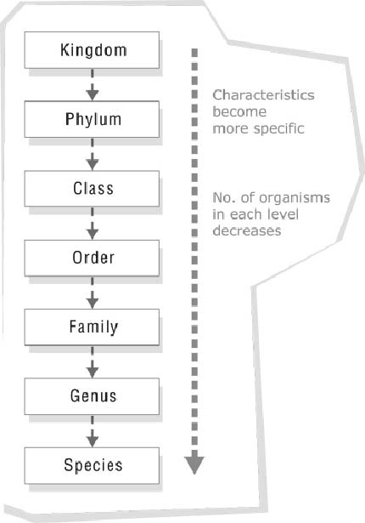
Levels of classiﬁcation
In the 18th century a system of classification was developed by Carl Linnaeus (1707–1778), a Swedish scientist. He used structural characteristics to place living things into groups or levels.

Starting with kingdom and working down to species there are seven major levels of classiﬁcation as shown. Since the classiﬁcation system starts with a large general group down to a small speciﬁc group it is known as a hierarchical system. Each successive level uses different criteria and contains organisms with more structural features in common.

Phyla (singular: Phylum) are major groups within a kingdom.

You will need to remember the levels of classification.

A pnemonic for recalling the levels is shown below. You may think of a better one.

Deviant - Domain  Kids - Kingdom  Playing - Phylum  Chasey - Class  On - Order  Freeways - Family  Get - Genus  Squashed! - Species | 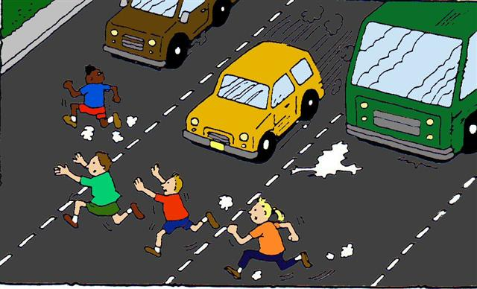

All organisms can be classiﬁed using the levels of classiﬁcation. The table below shows the classiﬁcation of humans.
Domain | Eukarya
Kingdom | Animalia
Phylum | Chordata
Class | Mammalia
Order | Primates
Family | Hominidae
Genus | Homo
Species | Homo sapiens

Humans belong to the same family as the great apes which include chimpanzees, bonobos, gorillas and orangutans.



Domains

The first division of living organisms in into the three domains – Eukarya, Archaea & Bacteria. These domains are based on cellular characteristics.
Organisms belonging to the Eukarya domain are referred to as eukaryotes. These organisms contain DNA (deoxyribonucleic acid) within a membrane bound nucleus and have distinct membrane bound organelles within the cell body.
Domains Archaea and Bacteria contain organisms known as prokaryotes.

Kingdoms

At one time all living things were grouped into two kingdoms: Plants and Animals. Differences between these two groups are shown in the table below.

Animals | Plants
Usually have freedom of movement | Lack ability to move from place to place
Cannot manufacture their own food | Manufacture food using sunlight energy
Flexible cell membranes | Rigid cell wall surrounds cell membrane
No chloroplasts | Many chloroplasts
Lack large vacuoles | Large ﬁlled ﬂuid vacuole
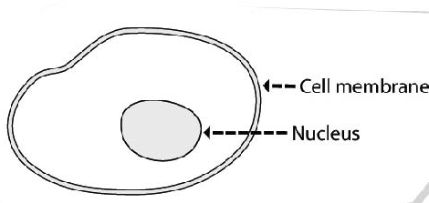 | 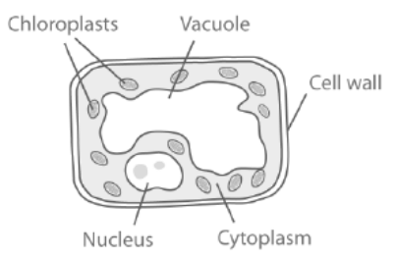

However, some organisms do not ﬁt into a two group system and a ﬁve kingdom system was suggested.

The ﬁve kingdom system
The 5 kingdoms are: Animals, Plants, Fungi, Monera and Protista as shown below.
Kingdom | 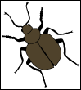  Animals |   Plants | 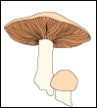  Fungi | 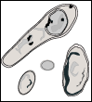  Monera | 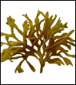  Protista
Examples | Multicellular animals | Moses  Ferns  Eucalyptus | Bread mould  Yeast mushrooms | Bacteria cyanobacteria | Protozoa  Algae

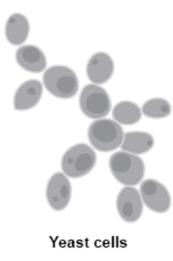

Kingdom Fungi
Fungi are an interesting group of organisms because although they have many features in common with plants, they do not carry out photosynthesis. So, like animals, they must consume food produced by other organisms.

Some Fungi are unicellular e.g. yeast and others are multicellular with thread like hyphae that grow below ground. The fruiting body, or mushroom, spreads the reproductive spores.

Kingdom Monera
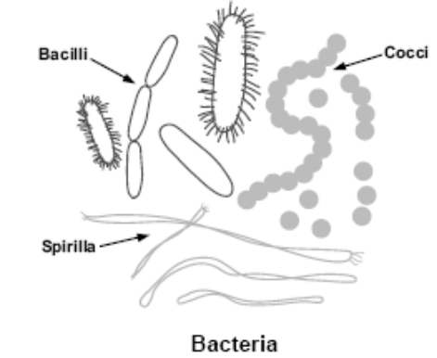
This group of organisms contains the prokaryotes. Kingdom Monera includes the microscopic bacteria, you could fit 100 of them across a full stop, and the cyanobacteria (blue-green algae).

Bacteria can be grouped according to their shape:
- cocci are round
- bacilli are long
- spirilla are spiralled.

Kingdom Protista
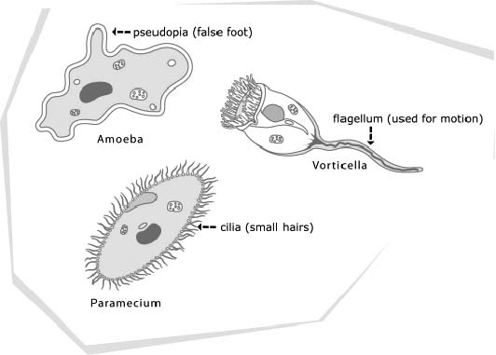

This group of organisms require moist environments to survive and contains eukaryotic organisms that lack the specialised features of the Animal, Plant or Fungi Kingdoms.

Some examples include
- the unicellular protozoans e.g. paramecium
- the plant-like algae e.g. kelp
- the fungi-like slime moulds.

Kingdom Animalia
Animals are multicellular heterotrophic eukaryotes. This means they are comprised of many specialised cells and are consumers (must feed on other organism, cannot make their own food). There is a huge variety of organisms within the animal kingdom. These organisms are further classified based on morphology (physical structures), phylogeny (evolutionary ancestry) and molecular data (DNA & amino acids).

In the animal kingdom there are several phyla each with their own distinguishing characteristics.

Phylum Chordata and phylum Arthropoda are detailed below.
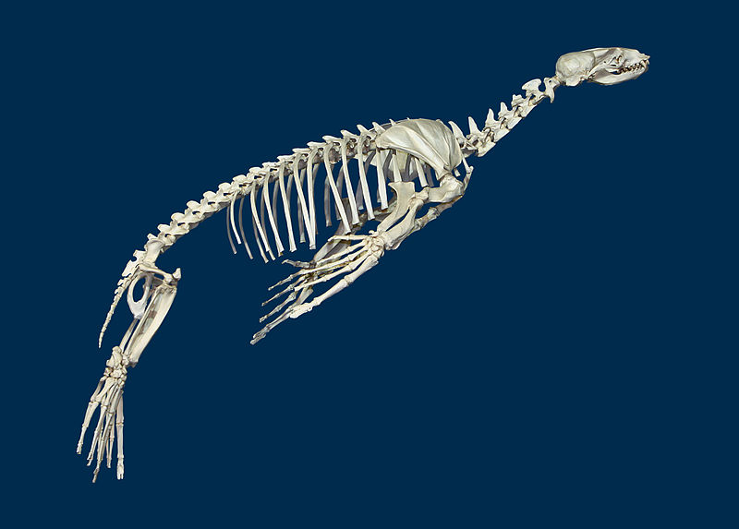

Phylum Chordata

15B All chordates share the following common characteristics:
- a notochord – a firm but flexible cartilage rod extending the length of the trunk
- two pairs of limbs usually present
- gill slits in the throat region at some time in their development
- a post-anal tail at some time in their development
- bilateral symmetry (distinct left and right side)
- complex digestive, circulatory and nervous systems.

Zalophus californianus by H. Zell available at https://commons.wikimedia.org/wiki/File:Zalophus_californianus_01.JPG CC BY-SA 3.0

The classes of chordates include:

Agnatha (pronounced ag-natha) Jawless fish e.g. lamprey, hagfish.
Chondrichthyes (kon-drik-thees) Cartilaginous fish e.g. Sharks and rays.
Osteichthyes (osty-ik-thees) Bony fish e.g. salmon, tuna, snapper.
Amphibia Amphibians e.g. frogs, newts, toads.
Reptilia Reptiles e.g. snakes, lizards, turtles.
Aves Birds e.g. parrots, emus, magpie.
Mammalia Mammals e.g. bandicoot, numbat, whale.

Phylum Arthropoda
arthro = joint poda = leg

Features all arthropods have in common include:
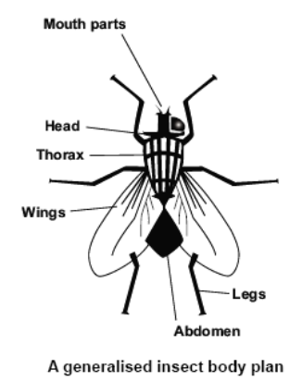

- bilateral symmetry (distinct left and right side)
- segmented bodies
- exoskeleton made of chitin- muscles are attached to the inside to allow movement.
- pairs of jointed appendages- in particular the legs.
- an open circulatory system – blood is pumped by the heart into large spaces where it bathes the organs and tissues.
- a main nerve cord close to the ventral surface (under side).

The two most important features are the jointed appendages and the tough exoskeleton.

Arthropods are divided into five classes based on the number of paired appendages and the number of body segments. For example, all arthropods in the insect class have three pairs of legs and three body parts. Crustaceans have five pairs of legs with the first pair
usually modified to function as pincers.

Kingdom Plantae
Plants are multicellular, non-motile organisms that are autotrophic. This means that they are able to manufacture their own food. They do this by harnessing light energy during photosynthesis. The members of the plant kingdom include moss, ferns, conifers and flowering plants.
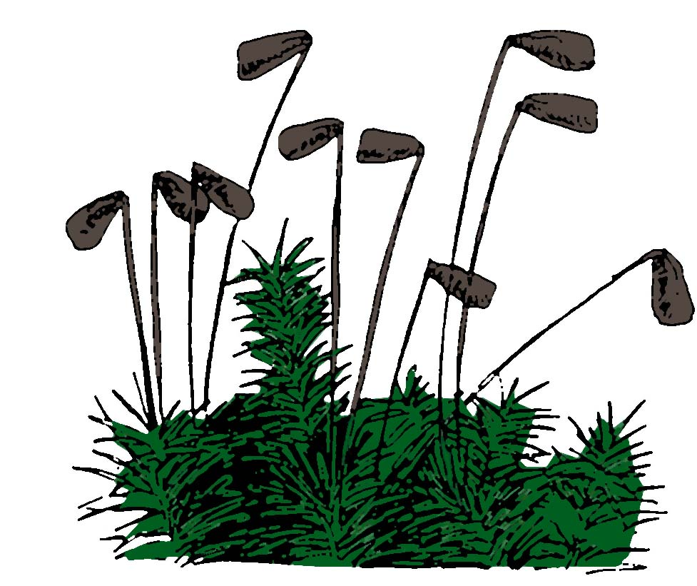

Moss (Bryophyta)
Although they are small, moss have leaf, stem and root like structures.
Moss produce spores and being non-vascular plants,
they need cool and damp environments.

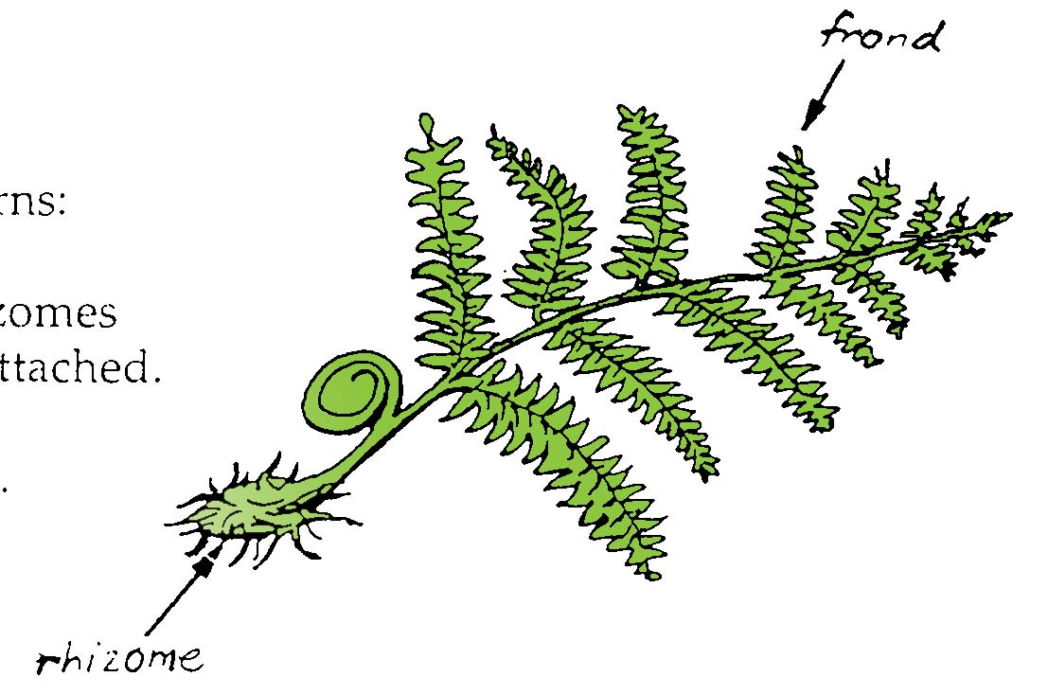
Ferns (Tracheophyta)
Ferns usually require moist surroundings to thrive.
Their leaves, or fronds, produce spores on the underside and the horizontal stems, called rhizomes are usually underground with roots attached.

Conifers (gymnosperms)
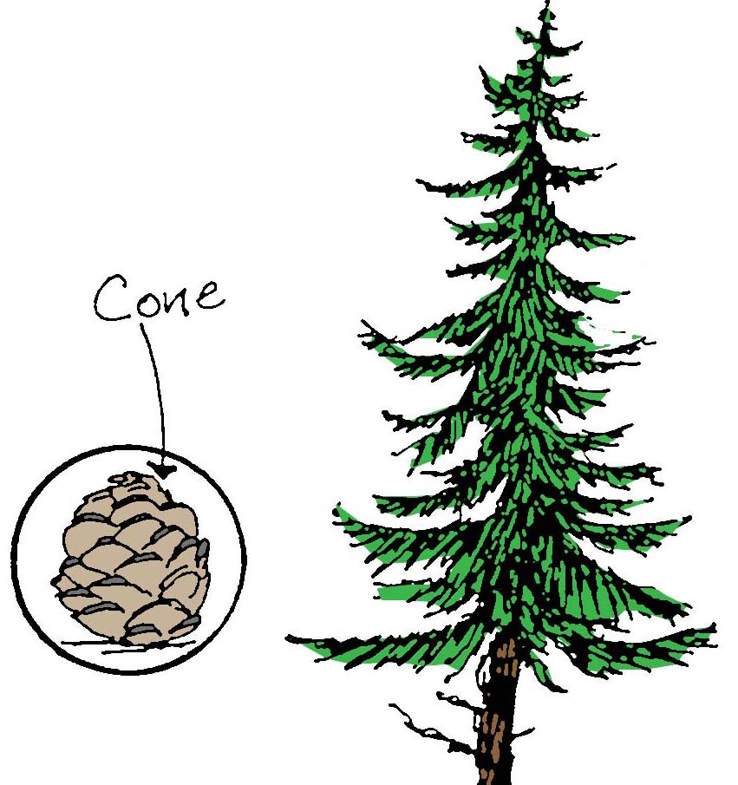
A common example is the pine tree.
The following are features of this group:
- Conifers produce unprotected or naked seeds.
• Most are wind pollinated.
• Most have leaves which are needle-like.
• Most are green all year round.

Flowering plants [angiosperms]
Flowering plants produce covered seeds and are divided into two groups:
- Monocotyledons or monocots with one seed leaf (cotyledon) on germinating.
- Dicotyledons or dicots with two seed leaves (cotyledons) on germinating.

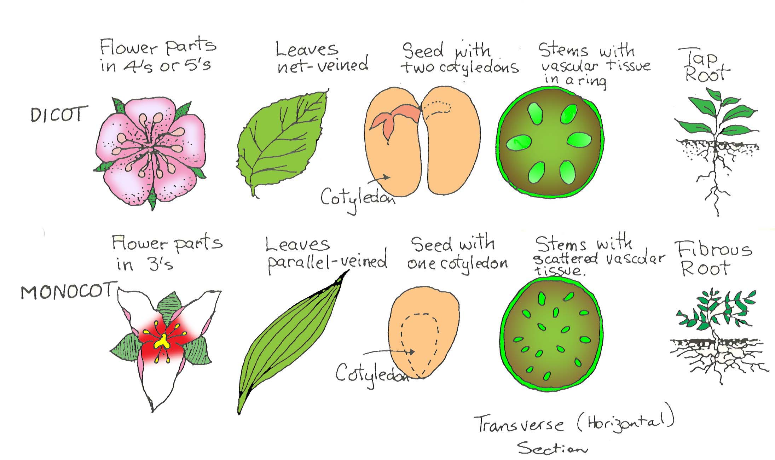

The species level
At the level of species there is a great deal of similarity between members. The species is the basic unit by which we can measure biodiversity.

A species is a consistently similar group of organisms which have the ability to produce fertile offspring in their natural environment. This means that members of the same species have many characteristics in common.

Naming of species (binomial nomenclature)

The scientific naming of organisms is known as the binomial system and was developed in the 18th century by Carl Linnaeus, the same man who produced the two kingdom system.
Binomial means two names where the ﬁrst name, capitalised, is the genus and the second name, lower case, usually describes some characteristic of the organism. The names are usually Latin, as this was the language of the time, and are written in italics e g Eucalyptus marginata – if you are handwriting then the names are underlined instead.

Why use scientiﬁc names?
By using scientiﬁc names scientists all over the world know that they are discussing the same organism because each scientiﬁc name applies to only one species.
A species is defined as a set of organisms that can interbreed and produce fertile offspring, e g all dogs belong to one species, but there are several species of kangaroos.
All dogs would be given one scientific name: Canis domesticus.
Different species of kangaroo would be given different scientific names e g Macropus rufus (red kangaroo) and Macropus fuliginosus (western grey). The genus name ‘Macropus’ means big foot which relates to all kangaroos.
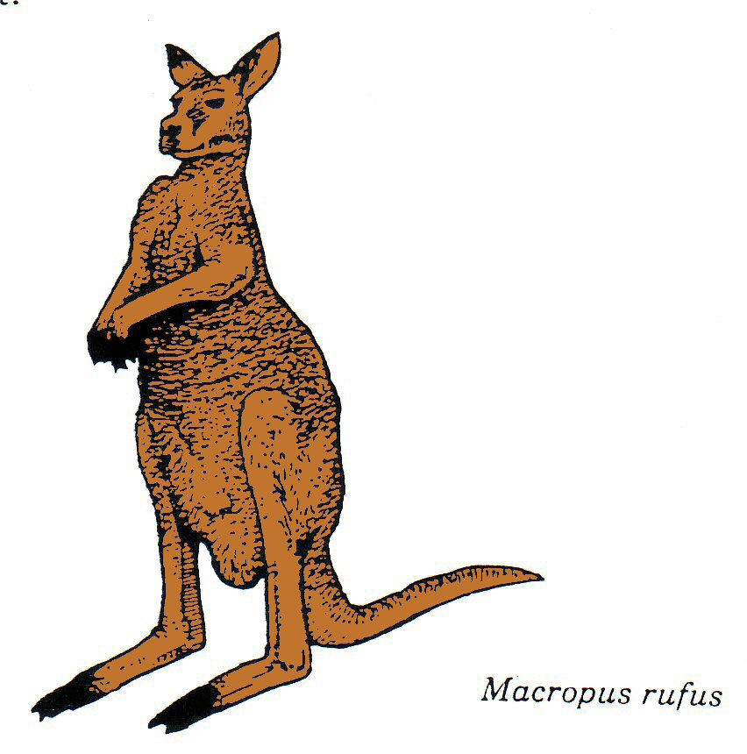

PRACTICE QUESTIONS:

- The correct way to write the scientiﬁc name for humans is
    - homo sapiens
    - Homo sapiens
    - Homo sapiens
    - Homo Sapiens

- Organisms that do not have a membrane bound nucleus are classified as:
  - viruses
  - prokaryotic
  - protista
  - eukaryotic

3. Scientists classify organisms into a number of groups that form a hierarchy. Which of the following shows the correct order of classification levels from specific to broad?

  - Domain, Kingdom, Phylum, Class, Family, Genus, Order, Species.
  - Species, Genus, Family, Class, Phylum, Order, Kingdom, Domain.
  - Domain, Kingdom, Phylum, Class, Order, Family, Genus, Species.
  - Species, Genus, Family, Order, Class, Phylum, Kingdom, Domain.

- Which of the following pairs of organisms are more similar? Explain your answer.
(a) Eucalyptus marginata and Caperea marginata
(b) Petaurus breviceps and Petaurus australis

- Eukaryotic cells have a distinct membrane bound nucleus. To which kingdom(s) do eukaryotic organisms belong?

Euglena is a unicellular micro-organism found in fresh water. It has a membrane bound nucleus, a ﬂagellum to move around, a gullet for feeding, chloroplasts and no cell wall.

In which kingdom would you place euglena? Explain your choice.

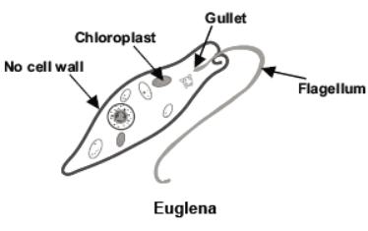

- The plant-like algae, kelp or seaweed, is multicellular and able to manufacture food using CO₂, H₂O and sunlight. Why is kelp not classified as a plant?
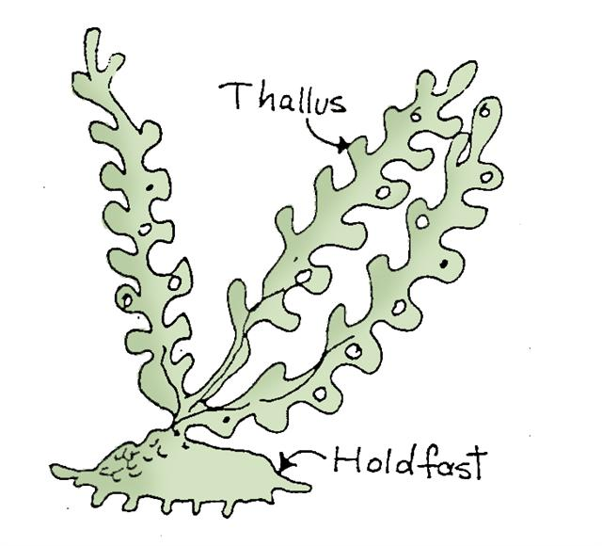

- Use your text or other resources to complete the table below for the five classes of Arthropoda.

Class | Example | Number of legs (as pairs)
Crustacea | Crayfish
Arachnida
Diplopoda | Millipedes | 2 per segment
Chilopoda | Centipedes | 1 per segment
Insecta

- Figure 2 shows three animals from the same phylum. Complete the table below then classify them into their classes.

Human | Dog | Frog
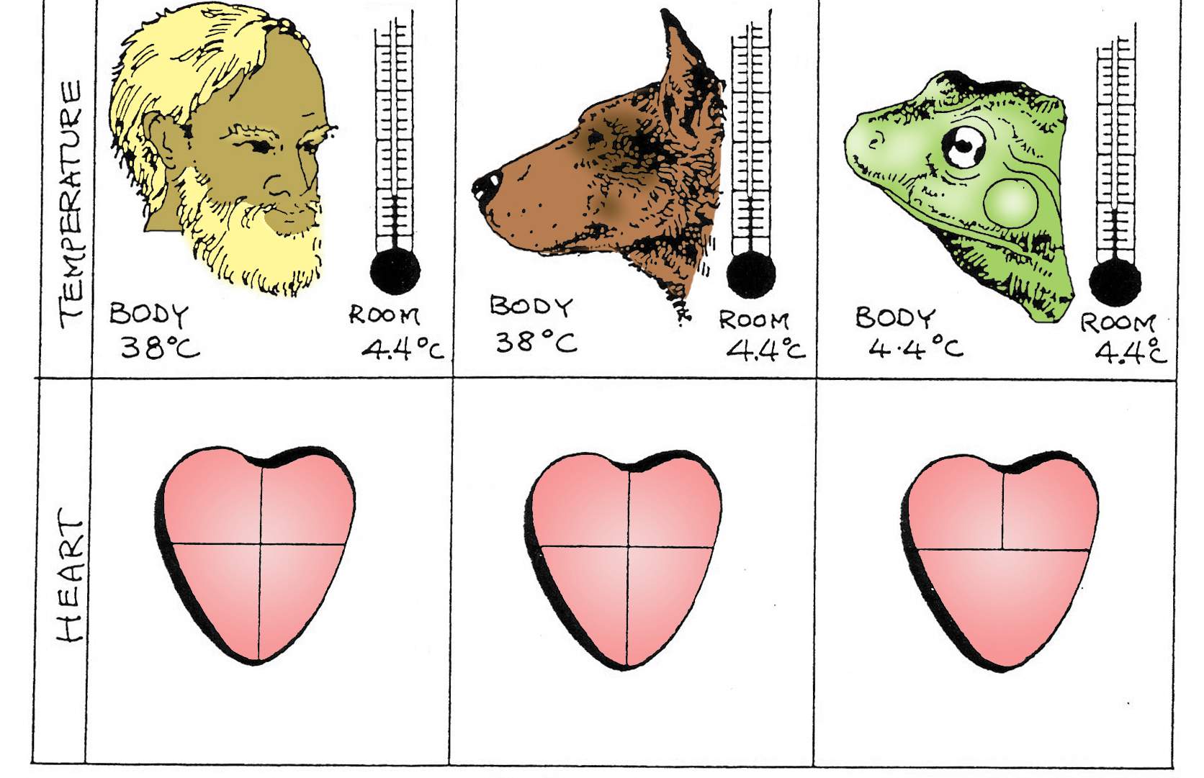
Figure 2

Characteristics | Animals
Characteristics | Human | Dog | Frog
a) Kind of body covering
b) Number of pairs of appendages
c) Number of chambers in heart
d) Kind of body symmetry
e) Comparison of body and environmental temperature | Same/different | Same/different | Same/different
Identify the phylum and class for each of the organisms.

Human: Phylum Class

Dog: Phylum Class

Frog: Phylum Class

- After much debate, a group of African plants previously included in genus Acacia has been re-classified as genus Vachellia. Use your knowledge of classification and the methods used to distinguish between species to explain how and why scientists changed the classification of this plant.

11. Give two reasons why the classification of organisms is important.

